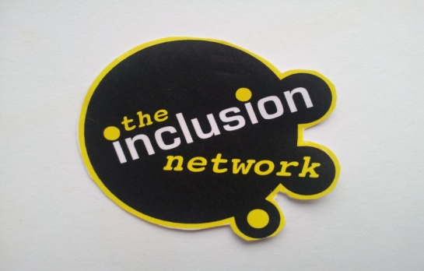
The Inclusion Network CIC
Company Registration Number
8354596

Community Consultation Event
When: Tuesday 27th August 2019
Where: Northfield Youth Centre, 200 King Avenue, Bootle. L20 0BY
Contact: theinclusionnetwork@live.com

Free refreshments provided

Why??
Since our last community consultation event held in December 2017 we received lots of feedback from the local community. This enabled us to access funding from 2 national funders; Sport England & The Morgan Foundation.
Since then we have been working hard to extend our lease, produce & submit plans to the local councils!
However, we are still just short of our financial target therefore over the next couple of months we will be hosting a number of fundraising events!

Pop down to see the plans for our new centre, provide feedback and make additional suggestions for the types of projects you would like to see running from our new youth and community centre!

See our GoFundMe story here; https://uk.gofundme.com/f/northfield-community-centre-extension

