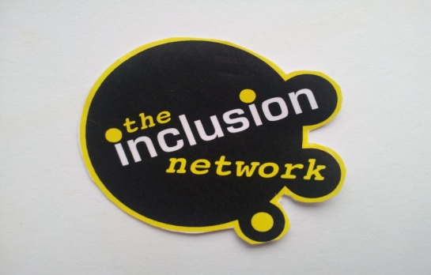
The Inclusion Network CIC
Company Registration Number
8354596

Our Sefton seal

Project overview

2020 is the year in which Sefton was the borough of culture for the Liverpool City Region (LCR) and the reason for our application to HLF. Our centre is based in Bootle which is an area, where many families and young people, are economically and socially disadvantaged, and we wanted to ensure they could become a part of Sefton’s cultural celebrations by participating in their own project.

The project planning began at the start of the year with trips and research sessions planned across May Half term and the School Summer holidays. Unfortunately, due to Covid 19 restrictions we had to push the project back, as trips were no longer viable. As restrictions began to ease during the summer holidays, the project leaders had discussions to be able to continue the project and planned Covid secure sessions over the next couple of months.

Despite the challenges, we were able to continue with the project and young people were able to participate in visits to cultural sites across the borough such as: Another Place, Crosby; Atkinson Museum, Southport; Croxteth Hall, Croxteth. The filming and research which was conducted during these visits enabled the young people to create their very own Sefton seal, which can be accessed via Prospero and will be shared locally via the community and via our own website, social media channels.

There was really positive feedback from the young people given in our evaluation event and many commented on how the project gave them the opportunity to meet with their peers for the first time in months, after what had been an extremely difficult time in their lives, when a lot of young people explained they felt lonely and isolated.

Please follow the link to access the project output; https://prospero.digital/library/9MdygENTFanCyrdvJ/PTe7Zxyz4Sj4y7bNj

See below for some pictures ….

